Q1. Create a hello world program in react.

import React from 'react';

import ReactDOM from 'react-dom';

import './index.css'; // Make sure to create this CSS file

function App() {

  return (

    <div className="App">

      <img src="https://upload.wikimedia.org/wikipedia/commons/a/a7/React-icon.svg" alt="React Logo" className="logo" />

      <h1>Hello World</h1>

    </div>

  );

}

Output:



Q2. Counter app.

import React, { Component } from 'react'

export class Class_state extends Component {

    constructor(){

        super();

        this.state={

            number:1,

        }

    }

    render() {

    return (

      <div>

        <hr />

        <h1>COUNTER APP</h1>

        <button onClick={()=>this.setState({number:this.state.number+1})}>Increment</button>

        <h1>{this.state.number}</h1>

        <button onClick={()=>this.setState({number:this.state.number-1})}>Decrement</button>

        <hr />

      </div>

    )

  }

}

export default Class_state

OUTPUT:

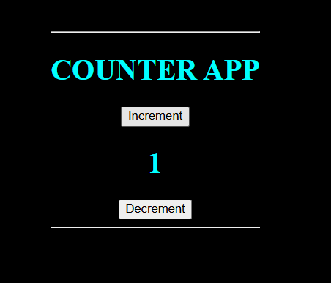

Q3. Create Login Lout React program as below

Main Component:

import Navigation from './Nav';

import PublicViews from './PubVe';

import PrivateViews from './PriVe';

import Footer from './Footer';

function App() {

  const [isLoggedIn, setIsLoggedIn] = useState(false);

  const handleLogin = () => {

    setIsLoggedIn(!isLoggedIn);

  };

  return (

    <div className="App">

      <Navigation isLoggedIn={isLoggedIn} handleLogin={handleLogin} />

      {isLoggedIn ? <PrivateViews /> : <PublicViews />}

      <Footer />

    </div>

  );

}

export default App;

Footer:

import React from 'react';

const Footer = () => {

  return (

    <footer style={{ padding: '10px', backgroundColor: 'blue', marginTop: '20px', width: '200px' }}>

      <p>Footer</p>

    </footer>

  );

};

export default Footer;

Private Views Component:

import React from 'react';

const Prive= () => {

  return (

    <div>

      <h2>Private Views</h2>

    </div>

  );

};

export default Prive;

Navigation:

import React from 'react';

const Navigation = ({ isLoggedIn, handleLogin }) => {

  return (

    <nav style={{ padding: '10px', backgroundColor: 'blue' , width: '200px', height:'50px',}}>

      <h2>Navigation</h2>

      <button onClick={handleLogin} style={{ padding: '10px', margin: '10px',marginLeft:'150px', markerEnd:'200px' }}>

        {isLoggedIn ? 'Logout' : 'Login'}

      </button>

    </nav>

  );

};

export default Nav;